Ron DeSantis
GOVERNOR

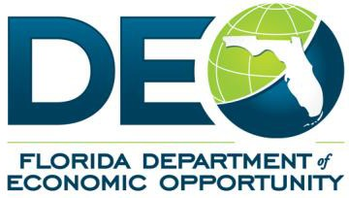
MEETING NOTICE AND AGENDA

Pre-Application Conference Request for Application 21-RFA 001
Florida Defense Reinvestment Grant Program
Ken Lawson
EXECUTIVE DIRECTOR

Meeting Time:
Thursday, February 27, 2020, 10:00 AM

Teleconference Information:
Toll Free Call-in Number: (888) 585-9008
Participant Code: 746162473

Purpose of Meeting:
The purpose of this meeting is for the Department of Economic Opportunity (DEO) to provide Prospective Applicants with an overview of the Florida Defense Reinvestment Grant (DRG) Program Request for Application (RFA) and the process for submitting replies to the RFA.

MEETING AGENDA

- Welcome and Introductions
- Overview of the RFA Process and Schedule
- Overview of the Florida Defense Infrastructure Grant Program
- Questions and Answers
- Wrap-up

Additional Instructions:
During the conference, prospective Applicants and interested parties will have the opportunity to present questions regarding this RFA and the Department will make a reasonable effort to provide answers at that time. However, any verbal answer or discussion provided during the conference is not binding on the Department. All questions presented during the conference must be followed by a written inquiry in accordance with the time, date, and place specified in the RFA, Section B.7., Questions.
Responses to all written inquiries or clarifications made to the RFA will be posted on DEO’s website at www.FloridaJobs.org/Military-Community-Programs, by the date specified in the RFA, Section B.5., Calendar of Events.

Florida Department of Economic Opportunity | Caldwell Building | 107 E. Madison Street | Tallahassee, FL 32399 850.245.7105 | www.FloridaJobs.org
www.twitter.com/FLDEO |www.facebook.com/FLDEO

An equal opportunity employer/program. Auxiliary aids and service are available upon request to individuals with disabilities. All voice telephone numbers on this document may be reached by persons using TTY/TTD equipment via the Florida Relay Service at 711.

