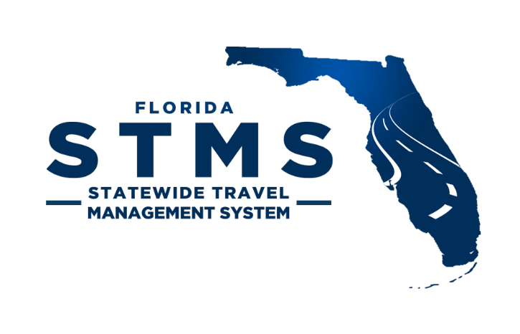
STMS – User Management Client
STMS Account Request
State Employee
☐ New Employee ☐ Existing Employee
User Information
First Name: Last Name:
Email:
PF ID (Log-in Number, not Employee ID):
FLAIR Org Code: <Information Pulled from People First>
Profile:
☐ Traveler ☐ Proxy Traveler ☐ Preparer
☐ Fiscal Accountant ☐ Auditor ☐ Reporter
If Approver, type:
☐ Reviewer ☐ Payment Approver ☐ Final Approver
Title: <Information Pulled from People First>
Supervisor:
Headquarter Information
City:
State:
☐ HQ is Home

Misc.
☐ Leadership
Sworn <Information Pulled from People First>
Protected <Information Pulled from People First>
Restricted <Information Pulled from People First>
Restricted Relative <Information Pulled from People First>

