Data Driven Program Design: A Brief History of TAA Data and Co-enrollment
9/21/2020

The Department has advocated for co-enrollment between the TAA Program and Dislocated Worker program since the Economic Dislocation and Worker Adjustment Assistance Act amended Title III of the Job Training Partnership Act (JTPA) in 1989. The TAA Final Rule, effective September 21, 2020, now makes co-enrollment mandatory.
Data Driven Program Design: A Brief History of TAA Data and Co-enrollment
by Susan Worden (OTAA Staff)
Today I’m going to tell a story that blends two of my favorite Trade program topics - Co-enrollment and Reporting! This story focuses on what we are constantly looking to expand on in OTAA, which is data-driven policy. To that end, I’m going give you the inside scoop on the data-strewn path that TAA has traveled with co-enrollment, culminating in the ambitious mandate of co-enrollment between Trade and Title I Dislocated Worker Programs that is now enshrined in TAA Regulations.
In the Office of Trade Adjustment Assistance, co-enrollment has long been a focus of policy interest. In fact, when I first joined policy unit of what was then the DIVISION of Trade Adjustment Assistance in 2003 (and after working a couple of years as a TAA investigator), our office was in the midst of conducting an extensive evaluation on the impact of co-enrollment on performance. Back then, we did not have reliable reporting on outcomes, much less co-enrollment! Instead, we had to rely on hiring a contractor to conduct state site visits, compile the results, and report back to the National Office. The whole evaluation took more than two years! And even then, the results reported were comprised of only a handful of states.
Fast forward to 2014 and 2015. In a one-two punch, both WIOA and TAARA 2015 are signed into law, aligning performance expectations and a number of other statutory reporting requirements between Trade and the Title I and Title III programs. In the wake of WIOA authorization specifically, OMB made it clear that DOL must focus on the alignment of programs in a manner that maximized coordinated service provision for all WIOA programs and Trade as well – which would play out in terms of how activities and outcomes were reported. As a result, the Participant Individual Record Layout was developed and implemented for WIOA programs. By 2018, TAA’s stand-alone reporting under TAPR was no more – instead all programs participating in PIRL were reporting through unified data elements, and giving states the option to report on participants served by multiple programs in a single unified quarterly file.
Following the implementation of the 2015 amendments, OTAA began to formulate issue papers that would expand on the new law through regulations. In tandem with this, my data team began to dig deep on the historical performance results of TAA co-enrollment. The scope of the effort focused on co-enrollment with Title I Dislocated Workers for many reasons (including the increased likelihood of early intervention and provision of important supportive services not available through Trade). What we saw through the data results was impressively consistent. As seen in this fact sheet, participants who were co-enrolled between Trade and DW performed outperformed participants that were not co-enrolled year after year. This was true based on Trade reporting (e.g. Trade Activity Participant Report 2009-2018) and reporting on DW (WIASRD 2009-2015). The availability of this data for co-enrolled participants heavily influenced ETA’s decision to recommend mandating co-enrollment in the Final Rule. And it was a significantly influential factor in obtaining approval of this mandate from both DOL Leadership and OMB. Essentially, it just made sense!
In recent years, ETA has conducted significant technical assistance on co-enrollment between Trade and DW, including the introduction of TAADI measures, best practice webinars, and fact sheets that were designed to help states overcome perceived barriers to co-enrollment. This has led to lots of conversation and concerns from states as to the challenges represented, including state and local environments that are hostile to coordination. It’s understandable to have some fear around this system change, but we ask that you have faith in the data that drove the decision to adopt the mandate in the new regulations- use it to have new conversations with partners. We all have the same goal, so let’s collaborate with the data as our foundation to develop a new infrastructure to support those impacted by trade find their new, improved career.
To close today’s blog, I’m going to provide a data graphic based on the most recent quarter of PIRL reporting, that provides context on the current state of co-enrollment between Trade and DW across the country. As can be seen, some states are in much better shape than others in achieving full co-enrollment. This helps inform what we have to build on from here. Please be assured that, as we have in the past, ETA will provide iterative goals to increase co-enrollment volumes, to provide forums for sharing challenges, and to develop products needed to grow their co-enrollment. We begin this effort now – in the next several weeks, look for a series of blogs on the TAA Community authored by Trade peers who will share how co-enrollment challenges are met in their states.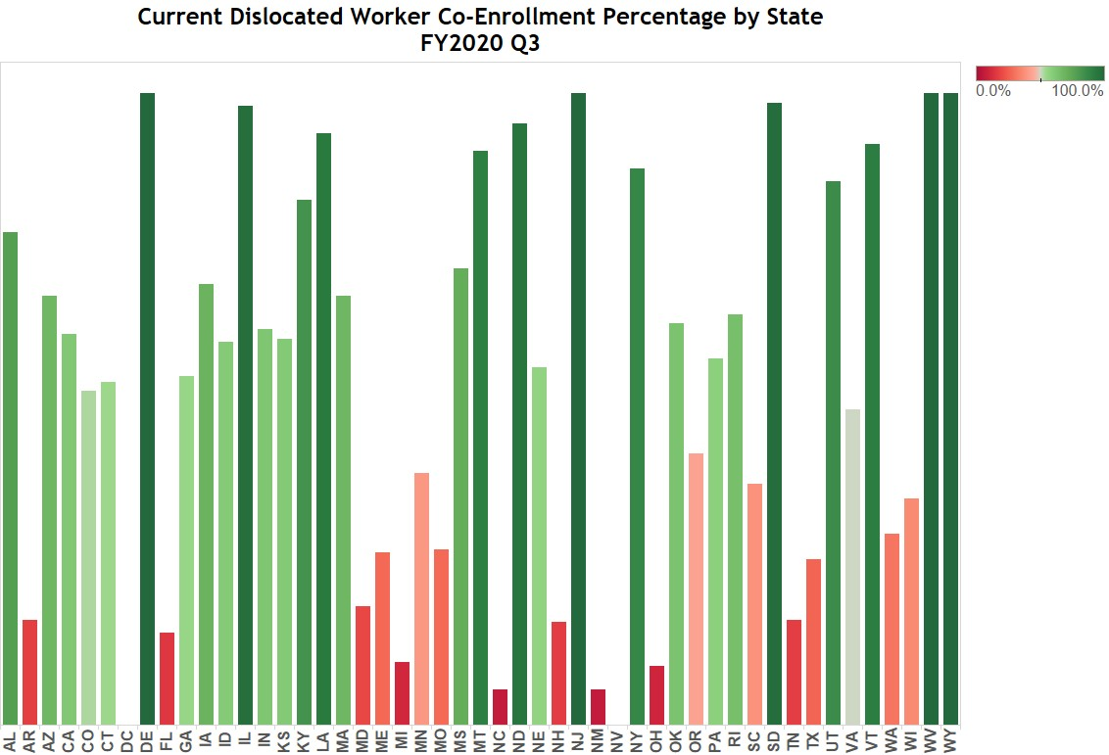

The regulatory requirement for co-enrollment is found at 20 CFR 618.325 (a)(1), “A State must co-enroll trade-affected workers who are eligible for WIOA's dislocated worker program.”
To assist states in this effort, the Department has revised the merit staffing provisions in the TAA Program regulations. Specifically, the Department has revised 20 CFR 618.890. The most notable change that will allow states to better integrate the TAA Program into WIOA and the American Job Centers (AJC) is in § 618.890(c).
§ 618.890(a): Staff employed under a merit personnel system as provided in section 303(a)(1) of the Social Security Act must be used for all reviews of benefit determinations under applicable State law.
§ 618.890(b):All determinations on eligibility for TAA Program benefits must be made by State staff, with the exception of the functions in paragraph (a) of this section, which must be made by staff meeting the criteria in paragraph (a) of this section.
§ 618.890(c): All other functions under the TAA Program, not subject to paragraphs (a) and (b) of this section, may be provided under a variety of staffing models.
The Final Rule means that costs for staff providing employment and case management services can be charged to the TAA Program regardless of their merit staff status. These staff can be state merit staff, state staff, local municipal staff, county staff, 501(c)(3) staff, community college staff, and even for profit entities that provide services through the AJC system.

