Model Local Manufacturing Development Program Ordinance
ORDINANCE NO. XXXXX
AN ORDINANCE OF THE CITY/COUNTY, FLORIDA, AMENDING THE LOCAL GOVERNMENT LAND DEVELOPMENT CODE, ESTABLISHING THE MANUFACTURING MASTER DEVELOPMENT PLAN APPROVAL PROCESS; PROVIDING FOR RECOGNITION OF VESTED PROPERTY RIGHTS; ESTABLISHING CRITERIA UPON WHICH TO APPROVE AN APPLICATION FOR A MANUFACTURING MASTER DEVELOPMENT PLAN; ESTABLISHING THE EFFECT OF APPROVAL OF A MANUFACTURING MASTER DEVELOPMENT PLAN; ESTABLISHING THE PERIOD FOR WHICH A MANUFACTURING MASTER DEVELOPMENT PLAN APPROVAL SHALL BE IN EFFECT; PROVIDING FOR COMPLIANCE; PROVIDING FOR TRANSMITTAL OF A COPY THIS ORDINANCE TO THE DEPARTMENT OF ECONOMIC OPPORTUNITY; PROVIDING FOR CONFLICTS; PROVIDING FOR SEVERABILITY; AND PROVIDING AN EFFECTIVE DATE.
WHEREAS, the establishment and maintenance of a strong and competitive manufacturing sector is essential to the viability and well-being of the community’s economic base; and
WHEREAS, the Local Manufacturing Development Program as created by Section 163.325, Florida Statutes, the Manufacturing Competitiveness Act (“Act”), is designed to assist local governments in the State of Florida to attract, establish, and maintain manufacturing enterprises, in furtherance of creating a competitive economic environment, resulting in increased employment opportunities and the general economic betterment of the City/County; and
WHEREAS, the purpose and intent of this Ordinance is to provide for the establishment of a Local Manufacturing Development Program for the City/County, through which manufacturers may obtain master development plan approval, as provided for by Section 163.325, Florida Statutes, the Manufacturing Competitiveness Act (“Act”); and
WHEREAS, this Ordinance, by providing for the establishment of a Local Manufacturing Development Program, recognizes the deterrents of risk, unpredictability, and excessive resource commitment to the establishment and expansion of manufacturing enterprises and establishes a process for the expeditious and predictable review and approval of manufacturing development projects and their future expansion; and
WHEREAS, the establishment of a Local Manufacturing Development Program, pursuant to the Act, entitles manufacturers and manufacturing developers to participate in the State’s coordinated manufacturing development approval process, intended to facilitate the expeditious receipt of those State permits necessary to establish or expand a manufacturing enterprise; and
WHEREAS, through the establishment of a Local Manufacturing Development Program, this Ordinance furthers the economic development strategy and manufacturing policy established in the City/County Comprehensive Plan; and
WHEREAS, this Ordinance is adopted to provide for the protection of the health, safety, and welfare of the citizens of City/County.
NOW THEREFORE, BE IT ENACTED BY THE COMMISSION/BOARD OF THE CITY/COUNTY OF CITY/COUNTY, FLORIDA, AS FOLLOWS:
SECTION 1: This Ordinance shall be known as the City/County Manufacturing Development Program Ordinance. The findings stated above are adopted and incorporated herein by reference.
SECTION 2: Section ___, Article ___ of the City/County Land Development Code, is hereby created to establish the manufacturing master development plan approval process, as follows:
Section 1. Purpose and intent. The manufacturing development plan approval process is intended to provide a quick, efficient, and comprehensive method whereby new manufacturing businesses may be established within a designated portion of the City/County and thereafter expanded with minimum further development review. The process ensures that manufacturing businesses will be supported with adequate facilities and infrastructure and that potential adverse impacts to natural resources and adjacent land uses are sufficiently mitigated.
The manufacturing master development plan enables master development approval, authorizing specified manufacturing uses at specified development intensities, for a specific site or geographic area. The approval of the master development plan constitutes a comprehensive approval; upon securing this approval, only building permits to ensure compliance with the State Building Code and any other applicable State-mandated life and safety code shall be required to build, operate, and subsequently expand or otherwise physically modify the manufacturing development established by the master development plan.
In conjunction with the local government manufacturing master development plan approval process, manufacturing businesses located within the designated area of the City/County eligible for approval pursuant to this Ordinance are eligible to apply for state-level permits through the state-level coordinated manufacturing development approval process established in Section 163.3253, F.S.
Section 2. Definitions.
(a) Applicant shall mean the manufacturer or manufacturing developer that applies for master development plan approval pursuant to this Ordinance.
(b) Application shall mean an application for master development plan approval for the purpose of developing new or expanding existing manufacturing uses within the specified area wherein manufacturing uses are authorized pursuant to this Ordinance.
(c) Local Government Development Approval shall mean all required local government development approvals necessary to initiate the development or expansion of a manufacturing use, consistent with the approved master development plan, other than building permits as may be necessary to ensure compliance with the state building code and any other applicable state-mandated life and safety code.
(d) Manufacturing use shall mean those land uses established for the purpose of conducting those businesses classified within Sectors 31-33 of the North American Industry Classification System.
(e) Manufacturer shall mean a business that is classified in Sectors 31-33 of the North American Industry Classification System and is located, or intends to locate, within the geographic boundaries of an area designated by a local government, as provided under Section 163.3252, F.S.
(f) Master Development Plan (“MDP”) shall mean that document that, upon approval by the City/County, pursuant to this Ordinance, authorizes manufacturing development within a specified geographic area and which sets forth applicable conditions, limitations, and standards.
(g) Master Development Plan Eligibility Area (“MDPEA”) shall mean that area within the City/County depicted on Map 1, included in Appendix I.
(h) Working Days shall mean calendar days excluding Saturdays, Sundays, and legal holidays.
Section 3. Applicability/Eligibility. Applications for establishment of a master development plan (“MDP”) shall comply with the following minimum eligibility criteria:
(a) Location within the MDPEA. An application may be made for any area of land located entirely within the boundaries of the MDPEA, shown on Map 1, included in Appendix I; and,
(b) Configuration of the MDP. The MDP may consist of either a single, discrete area of land, or of multiple discrete parcels or tracts, so long as each parcel or tract is located in the MDP eligibility area, and each discrete parcel or tract is of sufficient size and configuration to accommodate a principal use authorized in the MDP.
Section 4. Vested Rights. Those existing development rights authorized by the City/County before the approval of the MDP, and associated with the area of land included in an MDP application, shall be recognized as vested development rights, if so requested by the manufacturer.
Section 5. Application for Master Development Plan approval.
(a) Development Eligibility Form (DEF). The manufacturer intending to file a MDP application shall first apply for and obtain, from the City/County, a development eligibility form (DEF) documenting the applicant’s eligibility to participate in the manufacturing development program. The form shall certify eligibility, based upon: i) whether the site wherein the applicant is seeking to establish, expand, modify, or improve a manufacturing business, is located within the MDPEA; and, ii) whether the associated use of the property qualifies as a manufacturing use as defined herein.
The certification of eligibility to participate in the local government manufacturing development program form shall be recognized as certification of the applicant’s eligibility to participate in the state-level coordinated manufacturing development approval process as established in Section 163.3253, F.S.
(b) Preapplication conference. Upon obtaining a DEF affirming eligibility, the manufacturer intending to file a MDP application shall first schedule a preapplication conference with the City’s/County’s (Agency of Preference). At the preaplication conference, the manufacturer and staff will meet to discuss the manufacturer’s development plans and the application process. Staff will outline the applicable procedural steps for the development project, identify the application content requirements, identify criteria for approval, identify issues anticipated to arise during application review, and in collaboration with the manufacturer, establish a scope of review.
(c) Application process sequence. The application process consists of the following sequence: preapplication conference; the filing of the application by the applicant; staff’s review of the application to determine completeness; staff’s provision of notice to the public of receipt of the application; review by staff, who will provide a recommendation to the City/County elected commission as to whether the application should be approved; and, final determination by the City/County elected commission, at a public hearing, as to whether to approve the application.
(d) The application – function and content. The application for MDP approval shall include a site plan with a greater degree of detail but only to the extent necessary to achieve compliance with the purpose and intent of this Ordinance. This also includes zoning, permitting, concurrency, platting, and all other local government approvals prior to the issuance of a building permit. The application, required review submittals, and the review process shall be for a single unified staff review to avoid unnecessary costs, duplication, redundancy, waste of resources and to ensure efficiency in the approval process. Staff review shall be scheduled for completion and submittal for consideration by the City/County at a public hearing within (90-120) days of the application being determined complete, except and unless extended by mutual agreement of the applicant and the City/County.
Applications for MDP approval shall include the following:
i) A completed City/County application form.
ii) A site map with site boundaries identified and a legal description of the land included within the application along with proof of applicant’s ownership, and, as applicable, designation of an authorized agent.
iii) An itemized list of uses to be allowed in the MDP. Uses may be more limited than those allowed by applicable zoning, but not more expansive. In all instances, principal uses authorized pursuant to this section shall be limited to manufacturing uses, as defined herein.
iv) Authorized development intensity, in terms of total maximum square footage, floor area ratio, and height limits.
v) Development regulations and standards for the MDP, such as, minimum standards for buffers and perimeter landscaping, setbacks from perimeter boundaries, lighting, signage, and off-street parking.
vi) Identification of development impacts, if applicable to the proposed site, which the local government will require to be addressed, including but limited to:
(1) Drainage
(2) Wastewater
(3) Potable water
(4) Solid waste
(5) Onsite and offsite natural resources
(6) Preservation of historic and archaeological resources
(7) Offsite infrastructure
(8) Public services
(9) Compatibility with adjacent land uses
(10) Vehicular and pedestrian access
(11) Off-site transportation impacts
(e) Application -- Exceptional requirements. When applicable, the application for MDP approval shall also be required to comply with the following requirements:
(1) Planned Unit Development zoning district standards
(2) Final site plan requirements
(3) City/County environmental permitting requirements
(4) Concurrency management system requirements
(5) Platting and subdivision requirements
(6) Other City/County approvals as may be necessary, prior to the issuance of a building permit.
(f) Criteria for approval. In deciding whether to approve, approve with conditions, or deny a MDP application, the City/County elected commission shall determine whether the following criteria have been met:
i) That the application demonstrates that the entirety of the proposed development site is located within the boundaries of the MDP eligibility area, shown on Map 1 in Appendix I;
ii) That the land uses proposed in the application are limited to manufacturing uses, as defined herein, and consistent with section 163.3251(4), F.S., and any accessory uses clearly incidental to manufacturing uses;
iii) That the application demonstrates consistency with the Comprehensive Plan.
iv) That the application demonstrates compliance with the Land Development Code.
v) That the application demonstrates compliance with this Section.
(g) Decision to approve the application. The City/County elected commission shall, within (90-120) days of the MDP application being determined complete, hold a public hearing, to determine whether to approve the application. The elected commission’s decision shall consist of an approval, denial, or continuation to a date-certain to enable additional information to be provided, and shall be based upon the application demonstrating compliance with the criteria for approval, set forth in part (f), and testimony and material entered into the record at the public hearing. [Note: the local government may establish a threshold under which smaller or less intensive projects are subject to administrative review and approval.]
Section 6. Effect of approval of an application; rights, permissions, and obligations derived from Master Development Plan approval.
The approval of an MDP application by the City/County elected commission shall constitute a development order allowing the property owner to apply for and receive building permits for any portion or all of the development approved and authorized in the MDP without further review of development impacts addressed in the MDP, so long as the property owner submits, along with the building permit application, a certification, signed by a licensed architect, engineer, or landscape architect, attesting that the proposed development is in compliance with the MDP. The development order shall not exempt or exclude the property owner from compliance with those building permitting requirements necessary to ensure compliance with the state building code and any other applicable state-mandated life and safety code, nor shall it exempt the property owner from compliance with any State of Federal requirements as may be applicable.
Section 7. Development of the site consistent with the Master Development Plan approval.
The City/County shall ensure continuing compliance with a MDP through code enforcement and other activities as may be necessary, and may call, revoke, or cause the forfeiture of bonds or other securities provided by or on the behalf of the developer to ensure the satisfactory completion or implementation of the MDP and compliance with applicable regulations and standards.
Section 8. Expiration of Master Development Plan approval.
The MDP approval shall be in effect for a period of ten years from the date of issuance. [Section 163.3252(2)(f), F.S., requires a minimum period of 10 years; the local government may select a longer period, or choose not to have approvals expire] After the ten-year period has ended, no new physical development shall occur on those lands subject to the MDP, except as may be authorized by a building permit issued prior to the end of that period, or by the extension of the effective date through the modification of the approved MDP, as established in Section 9, or by approval of a new development application. Any physical development activities otherwise conducted after the expiration of the MDP approval shall be in violation of this Code and subject to those penalties and remedies provided therein.
Section 9. Modification of an approved Master Development Plan.
(a) A manufacturer may request to modify an approved MDP by filing an application with the City’s/County’s (Agency of Preference). The designated official of the City’s/County’s (Agency of Preference) shall approve the revision if it is consistent with the comprehensive plan, complies with the land development code, and has no adverse impacts in regard to those items specified in Section 5(d)vi of this Ordinance other than those previously identified during the MDP application process or prior modification to the MDP.
(b) In those instances wherein a requested modification represents potential adverse impacts in regard to those items specified in Section 5(d)vi of this Ordinance not previously addressed, the modification shall be reviewed subject to those requirements pertaining to a new application for MDP approval.
(c) In no instance shall the City/County require a modification to MDP, except and unless such modification is required in response to enactment of a state law or local ordinance addressing an immediate and direct threat to the public safety. In such instances, the modification shall be limited to those aspects necessary to bring the MDP into compliance with the newly enacted state law or local ordinance. Such modifications shall be subject to approval by the designated official of the City’s/County’s (Agency of Preference).
(d) Review of a proposed modification to a MDP shall be limited to the proposed amendment and shall not subject any other aspect of the approved MDP to further review.
Section 10. Repeal.
Consistent with Section 163.3253, F.S., this Ordinance, as embodied herein in Sections 1 through 11, may not be repealed until it has been in effect for at least 24 months.
Should the City/County repeal this Ordinance, any application for a MDP submitted to the Local Government before the effective date of repeal shall be reviewed in accordance with those provisions of the manufacturing master development plan ordinance in effect when the application was submitted. The manufacturer that submitted the application is entitled to participate in the manufacturing development coordinated approval process established in section 163.3253, F.S.
Section 11. Administration.
This section [the Manufacturing Development Program Ordinance, as embodied herein in Sections 1 through 11], shall be administered by City’s/County’s (Agency of Preference), and any successor department or agency, as delegated and authorized by the Chief Executive Officer of the City/County. The actions of that department in the administration of this section shall be construed to be the same as those of the City/County. Code enforcement and compliance activities related to the implementation of this section may be delegated to other departments by the Chief Executive Officer.
SECTION 3: Copy to Department of Economic Opportunity. The Clerk of the City/County is directed to forward a copy of this Ordinance to the Florida Department of Economic Opportunity, Division of Community Development, 107 East Madison Street, Tallahassee, Florida 32399-4128, within 20 days after enactment.
SECTION 4: Conflicts. All ordinances or parts of ordinances in conflict herewith be and the same are hereby repealed.
SECTION 5: Severability. If any provision or portion of this ordinance is declared by any court of competent jurisdiction to be void, unconstitutional, or unenforceable, then all remaining provisions and portions of this ordinance shall remain in full force and effect.
SECTION 6: Effective Date. This ordinance shall become effective __________________.
INTRODUCED in the City/County Commission on the Xth day of Month, A.D., 2014.
PASSED in the City/County Commission on the Xth day of Month, A.D., 2014.
APPENDIX I
Map 1. MDP Eligibility Area
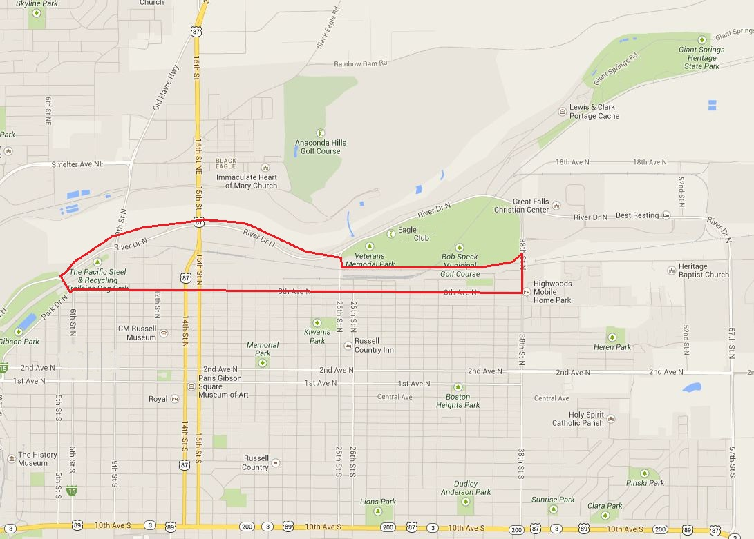
Key:
Boundary of MDP eligibility area. An application for an MDP may only be made for lands located entirely within the boundaries of the MDP eligibility area

