- Social Media Content
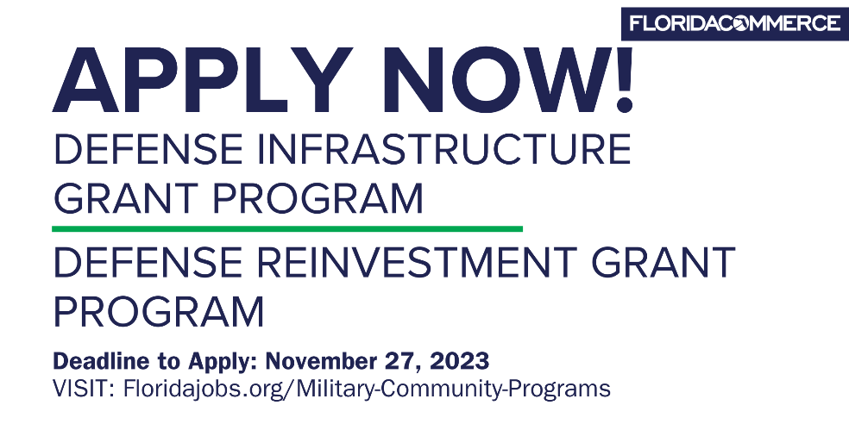

Copy: Attention Florida Military Communities!
Apply now for the Defense Reinvestment Grant Program and Defense Infrastructure Grant Program to protect and support military installations and communities. Deadline to apply is Monday, November 27, 2023 >> LINK

Copy: Attention Florida Military Communities!
Attention Military Communities! The Defense Infrastructure Grant Program funds local infrastructure projects that contribute positive impact on the value of Florida military installations and communities. Apply now >> LINK

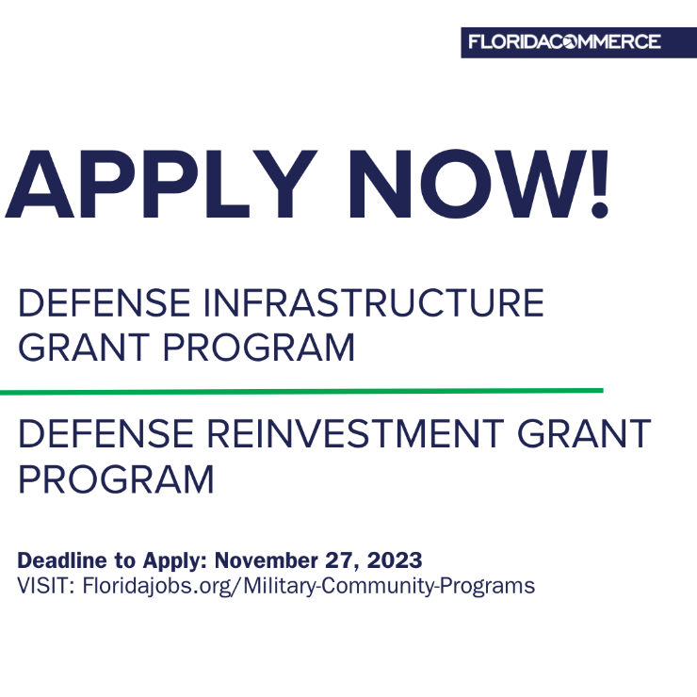

Copy: Attention Florida Military Communities!
Attention Military Communities! The Defense Reinvestment Grant Program provides support for community-based activities that protect existing military installations and support the economic development of military communities. Apply now >> LINK

- Direct Communication

Subject Line: Applications Now Open for Military Community Programs through FloridaCommerce

Community Partner,

FloridaCommerce recently announced that the application cycle for funding through the Defense Infrastructure Grant and Defense Reinvestment Grant Programs is now open. Applications will be accepted through November 27, 2023, and additional information is available on the Military Community Programs webpage.

The Defense Infrastructure Grant Program (DIG) supports local infrastructure projects that make a positive impact on the military value of installations within the state by addressing encroachment, transportation and access, housing, utilities, communications, environment, and security needs. Funds are used for projects that benefit both local communities and military installations.

Previous, DIG awards include:

- $500,000 for the City of Key West’s initiative to replace an existing structure with a reinforced Community Center Resilience Hub.
- $500,000 for the Florida Space Coast’s development of a Natural Gas Study, which will create a long-term master plan for safely and cost-effectively supplying liquified natural gas to launch pads.
- $500,000 awarded to Clay County for the construction of asphalt roads to repair deteriorating road surface, increasing the support for high weight vehicles associated with emergency response.

The Defense Reinvestment Grant Program (DRG) provides support for community-based activities that protect existing military installations, diversify the economy of a defense-dependent community, or develop plans that facilitate the reuse of closed or realigned military installations, such developing and implementing strategies that will help communities support the mission of military installations.

Previous, DRG awards include:

- $84,000 awarded to the Florida Space Coast’s development of a Wastewater Treatment Phase 2 Capture Plan and executing an Economic Development Commission communications plan.
- $125,000 awarded to Miami Dade County for the creation of presentations, plans, and analyses to plan for the development of the Miami-Dade Aerospace Technology Hub.
- $125,000 to Okaloosa County for their initiative to produce entrepreneur start-up videos associated with the Technology Coast Manufacturing and Engineering Network.

Dedicated staff is available to provide technical assistance throughout the application process. For additional questions about the application process, please contact DefenseGrants@Commerce.fl.gov. We look forward to assisting you as you develop your project to support and protect Florida’s military communities.

To learn more and apply, visit the Military Community Programs webpage.

c. Leave Behind Flyer – See Attached

